* **Config** (file @configuration)
  + Define messageSource()

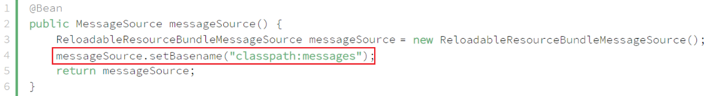

*messages.properties & messages_vi.properties*

* + Define LocalValidatorFactoryBean

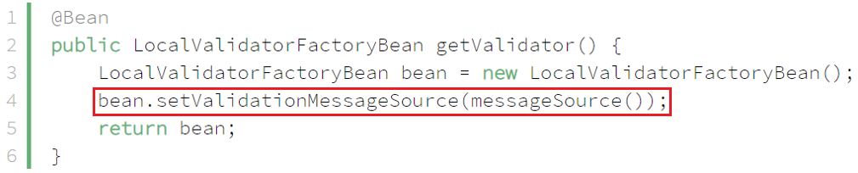

* **Reference**

<https://www.baeldung.com/spring-custom-validation-message-source>